**DATABASE MANAGEMENT SYSTEM**

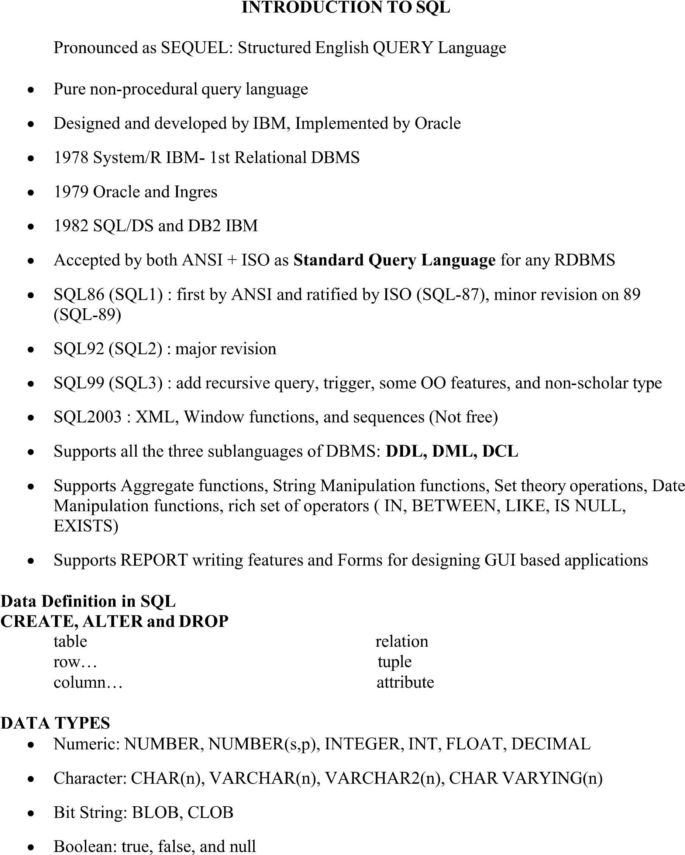

SQL QUERIES

1. CREATE DATABASE databasename;

Eg: CREATE DATABASE db1;

1. DROP DATABASE databasename;

Eg: DROP DATABASE emp;

1. CREATE TABLE table_name (column1 datatype,column2 datatype, column3 datatype,...);

Eg: CREATE TABLE Persons (PersonID int, LastName varchar(25),

FirstName varchar(25),Address varchar(25),City varchar(25));

1. DROP TABLE table_name;

Eg: DROP TABLE Shippers;

1. ALTER TABLE table_name;

Eg: ADD column_name datatype;

1. SELECT * FROM table_name;

Eg: SELECT * FROM Shippers;

1. SELECT column1, column2, ... FROM table_name WHERE condition;

Eg: SELECT * FROM Customers WHERE Country='Mexico';

1. INSERT INTO table_name (column1, column2, column3,…) VALUES (value1,value2,value3,…);

Eg: INSERT INTO Customers (Name, Contact, Address,City, PostalCode, Country)VALUES ('Cardinal', 'Tom B. Erichsen', 'Skagen 21', 'Stavanger', '4006', 'Norway');

1. UPDATE table_name SET column1 = value1, column2 = value2, ...WHERE condition;

Eg: UPDATE Customers SET ContactName = 'Alfred Schmidt', City= 'Frankfurt' WHERE CustomerID = 1;

1. DELETE FROM table_name WHERE condition;

Eg: DELETE FROM emp WHERE age=‘12’;

MySQL Grant Privilege

MySQL has a feature that provides many control options to the administrators and users

on the database. We have already learned how to create a new user using CREATE

USER statement in MySQL server. Now, we are going to learn about grant privileges to

a user account. MySQL provides GRANT statements to give access rights to a user

account.

GRANT Statement

The grant statement enables system administrators to assign privileges and roles to

the MySQL user accounts so that they can use the assigned permission on the

database whenever required.

Syntax

The following are the basic syntax of using the GRANT statement:

1. GRANT privilege_name(s)

2. ON object

3. TO user_account_name;

PROGRAM:-01

AIM:- Program to create a table called Employee with the following structure.

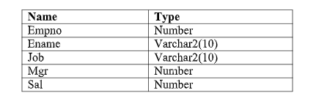

a. Add a column commission with domain to the Employee table.

b. Insert any five records into the table.

c. Update the column details of job

d. Rename the column of the Employee table using the alter command.

e. Delete the employee whose Empno is 106.

PROGRAM CODE:-

SQL> create table employee(empno number,ename varchar2(10),job varchar2(10),mgr number,sal number);

SQL> desc employee;

SQL> alter table employee add(commission number);

SQL> desc employee;

SQL> insert into employee values(&empno,'&ename','&job',&mgr,&sal,'&commission');

SQL> insert into employee values(&empno,'&ename','&job',&mgr,&sal,'&commission');

SQL> insert into employee values(&empno,'&ename','&job',&mgr,&sal,'&commission');

SQL> insert into employee values(&empno,'&ename','&job',&mgr,&sal,'&commission');

SQL> insert into employee values(&empno,'&ename','&job',&mgr,&sal,'&commission');

SQL>update employee set job=’traniee’ where empno=101;

SQL> select * from employee;

SQL> alter table employee rename column mgr to manager_no;

SQL> delete employee where empno=106;

SQL> select * from employee;

OUTPUT

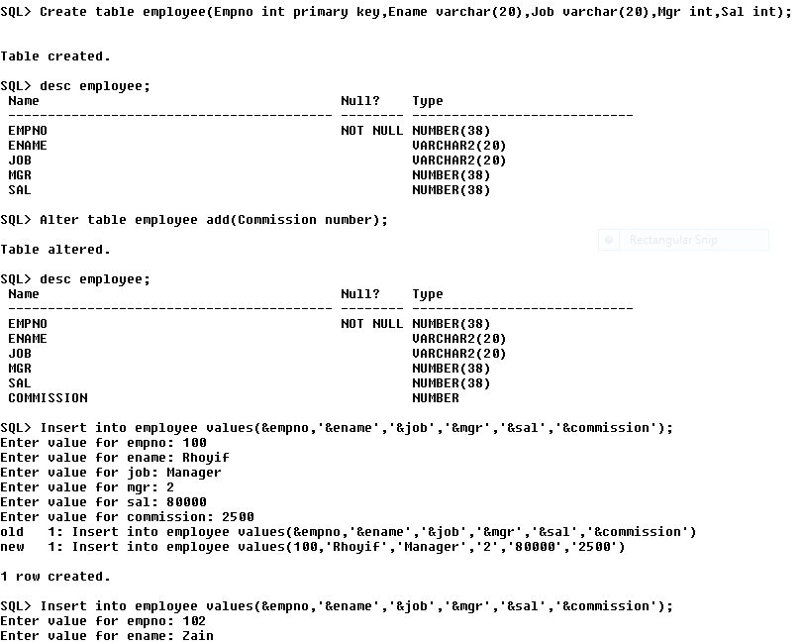

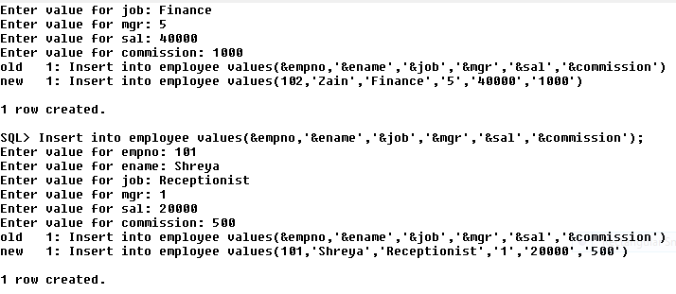

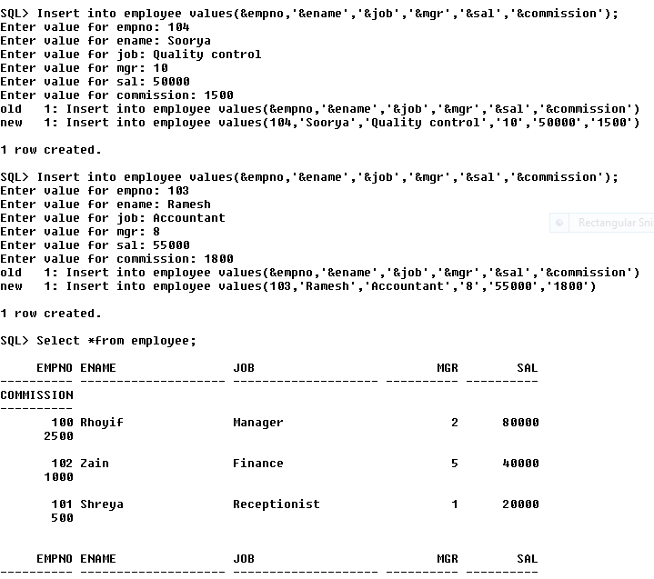

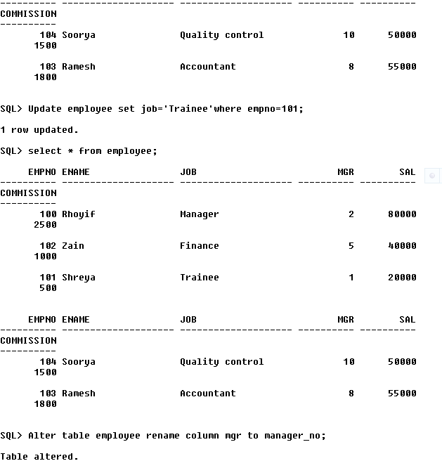

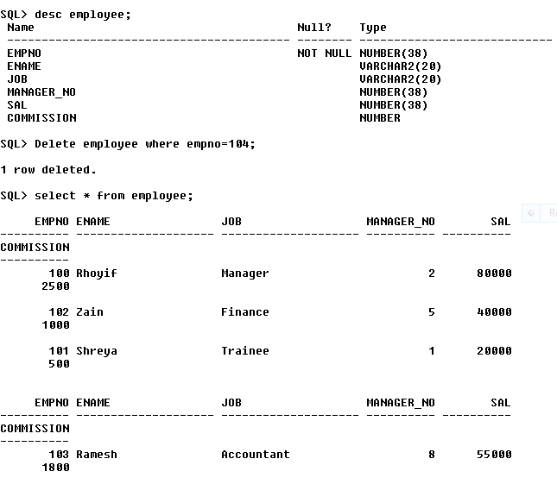

RESULT

Program executed successfully.

PROGRAM:-02

AIM:- Create a department table with the following structure.

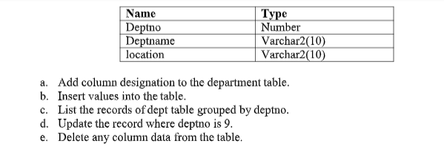

PROGRAM CODE:-

SQL> create table department(deptno number,deptname varchar2(10),location varchar2(10));

SQL> desc department;

SQL> alter table department add(designation varchar(10));

SQL> desc department;

SQL> insert into department values(&deptno,'&deptname','&location','&designation');

SQL> insert into department values(&deptno,'&deptname','&location','&designation');

SQL> insert into department values(&deptno,'&deptname','&location','&designation');

SQL> insert into department values(&deptno,'&deptname','&location','&designation');

SQL> insert into department values(&deptno,'&deptname','&location','&designation');

SQL> select * from department;

SQL> select deptno,deptname from department group by deptno,deptname;

SQL> update department set designation='accountant' where deptno=4;

SQL> select * from department;

SQL> alter table department drop(designation);

SQL> select * from department;

OUTPUT

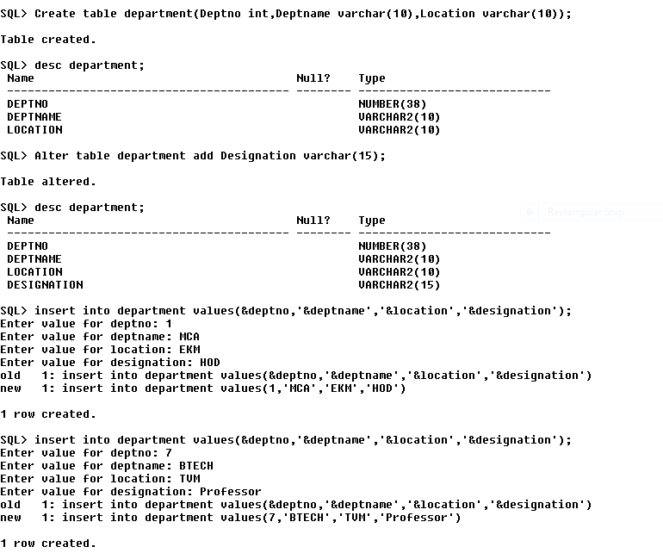

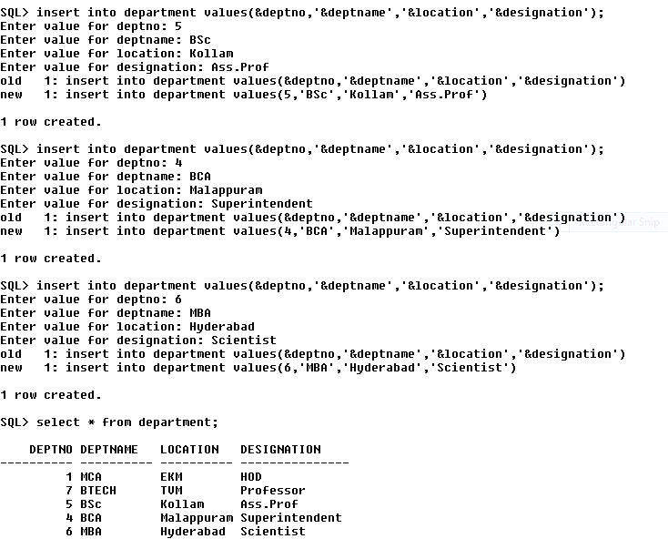

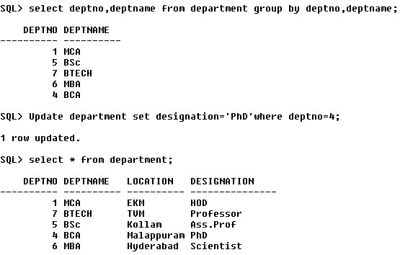

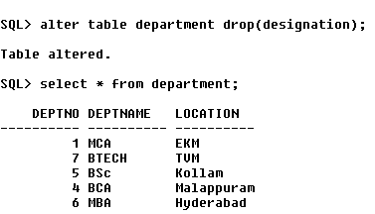

RESULT

Program executed successfully.

PROGRAM:-03

AIM:- Create a Employee table with the following structure.

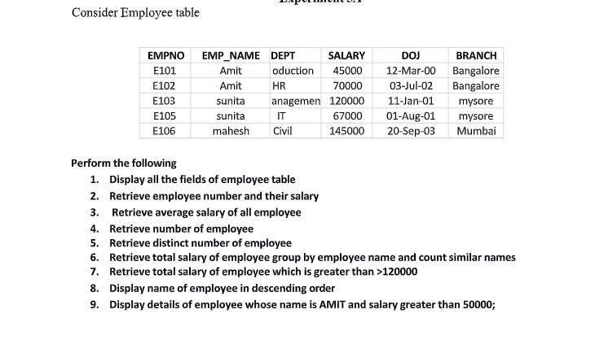

PROGRAM CODE:-

SQL> create table Employe(empno varchar(5),emp_name varchar(10),dept varchar(10),salary int,doj date,branch varchar(15));

SQL> alter table Employe modify doj varchar(10);

SQL> desc Employee;

SQL> insert into Employe values('E101','Amit','oduction',45000,'12-Mar-00','Banglore');

SQL> insert into Employe values('E102','Amit','HR',70000,'03-Jul-02','Banglore');

SQL> insert into Employe values('E103','Sunita','management',120000,'11-Jan-01','Mysore');

SQL> insert into Employe values('E105','Sunita','IT',67000,'01-Aug-01','Mysore');

SQL> insert into Employe values('E106','Mahesh','Civil',145000,'20-Sep-03','Mumbai');

SQL> select * from Employe;

SQL> select empno,salary from employe;

SQL> select avg(salary) from employe;

SQL> select count(*) from employe;

SQL> select count(distinct emp_name)from employe;

SQL> select emp_name,sum(salary),count(*)from employe group by(emp_name);

SQL> select emp_name,sum(salary)from employe group by(emp_name) having sum(salary)>120000;

SQL> select emp_name from employe order by emp_name desc;

SQL> select * from employe where emp_name='Amit' and salary>50000;

OUTPUT

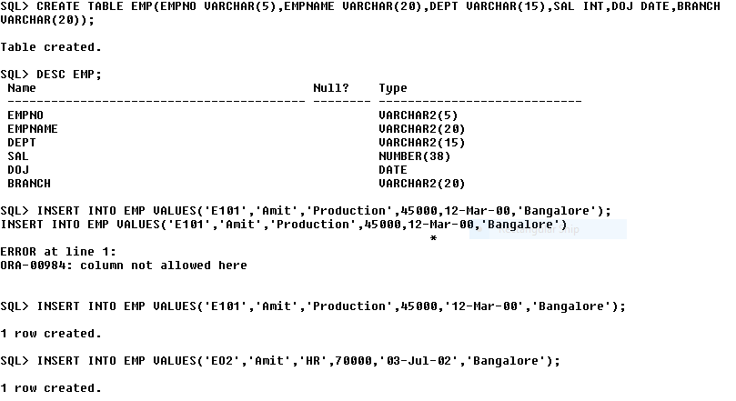

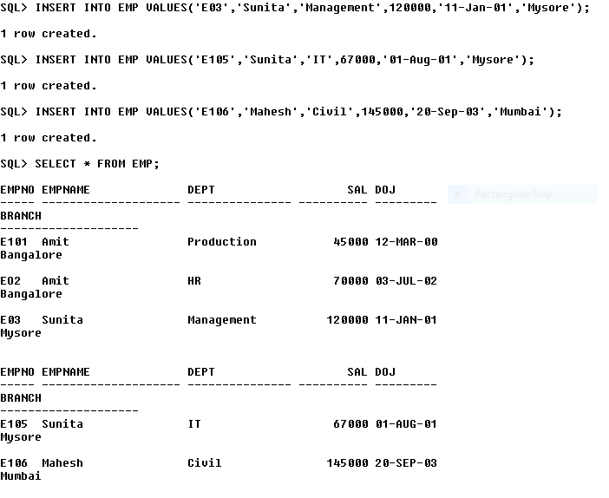

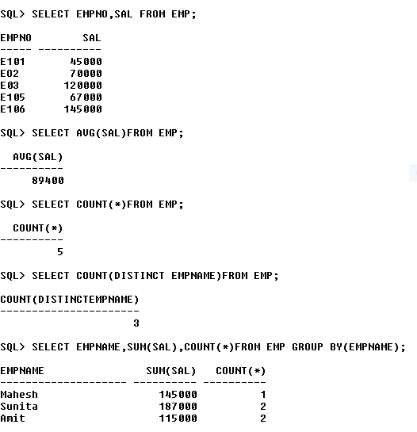

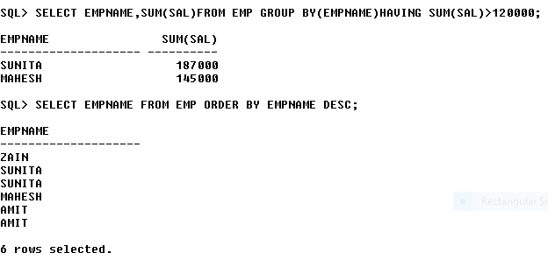

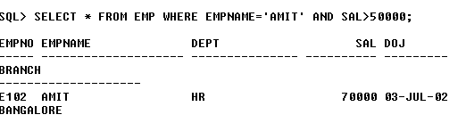

RESULT

Program executed successfully.

PROGRAM:-04

AIM:- Program to execute grand permission.

PROGRAM CODE:-

mysql> create user ‘soorya@localhost’ identified by ‘Soorya@23’;

mysql> show grants for ‘soorya@localhost’;

mysql> grants all on soorya.* to soorya@localhost;

mysql> show grants for ‘soorya@localhost’;

mysql> grants all on soorya.* to ‘soorya@localhost’;

mysql> show grants for ‘soorya@localhost’;

mysql> select * from tb;

OUTPUT

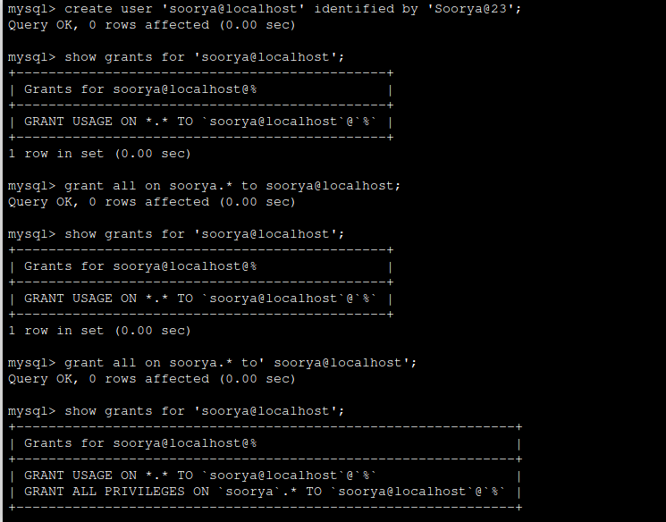

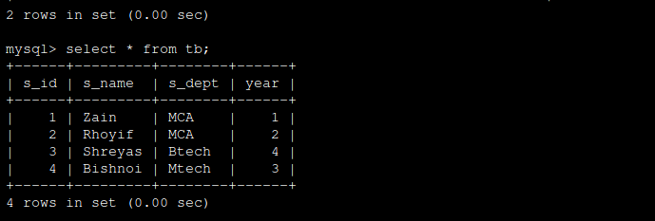

RESULT

Program executed successfully.